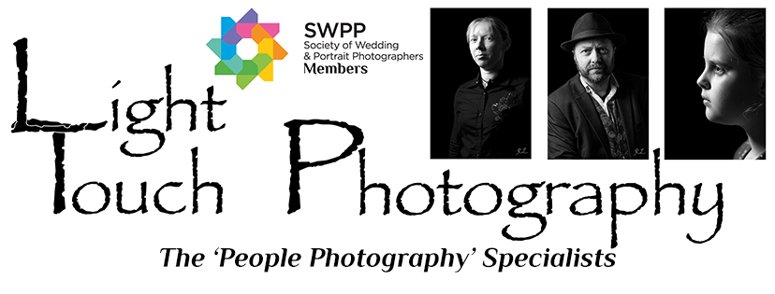

Wedding Photography Terms & Conditions
It is agreed that the following terms & conditions set out the total agreement made between the parties and that no variation or modification of this contract shall be effective unless agreed by both parties in writing.

Applicable Law
This contract is written in the United Kingdom and is subject to UK (English) Law. The terms & conditions set out below are a binding agreement between the parties and must comply with English Law. Where any discrepancy between the terms of this contract and English Law apply, English Law will be the defining law.

Special Requests / Coverage
The client understands and accepts that the photographic coverage will be as the photographer’s professional expertise determines and that no one photograph will be deemed more important than another. Special requests are not binding instruction, although every effort is made to comply with the client’s wishes.

Definition
The ‘Shoot’ refers to a wedding, portrait session, event to be photographed or any other situation where the services of our photographer(s) have been booked.

Booking Fee
The booking fee secures the time and services of the Photographer(s) for the shoot and is non-refundable or transferable, in the event of cancellation. Cancellation of the booking, less than 12 weeks before the shoot, will result in the full payment being due. All cancellations must be in writing. Shoots that are postponed to a later date will retain the fee as long as the photographer(s) can re-schedule for the new date and time.

Payments
Following payment of the booking fee, the balance of fees is to be paid 14 days prior to the shoot. No photographs will be delivered until all payments due have been paid in full. Payment for additional images is to be made when they are ordered.

Display
The Client hereby grants to Light Touch Photography and its legal representatives and assigns the irrevocable and unrestricted right to use and publish photographs of the Client and any invited guests or in which the Client or invited guests may be included, for editorial, trade, advertising and any other purpose and in any manner and medium; to alter the same without restriction; and to copyright the same. The Client hereby releases Light Touch Photography and its legal representatives and assigns from all claims and liability relating to said photographs.

Images
All image sizes are nominal. The Photographer(s) will provide a pleasing colour balance but cannot guarantee exact colour matching owing to anomalous reflectance caused by a combination of certain dyes and materials especially man-made fibres. It is sometimes impossible to record on film or digitally the exact colour as seen by the human eye.

Finishing of Images
Light Touch Photography will carry out an initial edit of all photographs that are to be offered to the client. This may include, at their discretion, adjustments to colour balance, contrast, exposure, and sharpness or any other editing that the photographer(s) deems necessary or desirable. The photographer will present finished images to the client.

Previews
Although the photographer will do his best to produce more proofs / preview images than set out in the website package, promotion, or as discussed with the client, there is no guarantee that any particular number of proofs / preview images will be produced.
Retouching
Retouching, digital manipulation and artist finishing is available to the Client as an optional extra.

Reorders
All reorders shall be treated as an extension of this contract and no responsibility for error will be accepted unless orders are given in writing.

Copyright
Any images or copies of images whether stored digitally or otherwise and any computer program including any source or object code, computer files or printed documentation relating to such images are protected by the Copyright and Design Act 1988. It is contrary to the Act to copy, or allow to be copied, photographically, electronically or by any other means an image created as part of this contract without the permission of The Photographer(s) in writing.

Licence
The Photographer(s) shall be granted artistic licence in relation to the poses photographed and the locations used. The Photographer’s judgment regarding the locations / poses and number of images taken shall be deemed correct. Due to the vagaries of the weather and the willingness of subjects it may not be possible to capture all the images requested.

Force majeure or Act of God
The due performance of this contract is subject to alteration or cancellation by either party owing to any cause beyond their control.

Attendance
In the unlikely event of the assigned Photographer(s) being unable to attend your shoot due to unforeseen circumstances, we reserve the right to appoint another photographer to attend your shoot on our behalf to undertake the photography to his / her best ability.

Limitation of Liability
In the unlikely event of a total photographic failure or cancellation of this contract by either party or in any other circumstance the liability of one party to the other shall be limited to the total value of the contract. Neither party shall be liable for indirect or consequential loss.

Cancellation
The Client may cancel this contract at any time by giving written notice to The Photographer(s) but in doing so shall forfeit any monies paid. Cancellation less than 12 weeks before the shoot will result in the full payment being due.

Negatives / Digital Files
Negatives / digital files remain the property of Light Touch Photography.

Prices
All prices are subject to the then current rate of V.A.T. (if applicable).

Complaints
Any complaints should first be raised by the Client with the Photographer(s) in writing within 21 days from the date of receipt of images. In the unlikely event of an unresolved complaint the Client may request the Society of Wedding and Portrait Photographers to mediate but only on the basis that its decision shall be final and binding upon both parties.

The terms of this contract are accepted by :-

CLIENT …………………………………………………………………………..
DATE………………………………Signature………………………………….
Address ……………………………………………………………………………………………….……………………………

For and on behalf of Light Touch Photography: DATE………………………………. Signature…………………………………..
Address: Broadgates Studio, 12 Queens Road, Tunbridge Wells, Kent, TN4 9LU. 01892 522776

